Base Model Performance
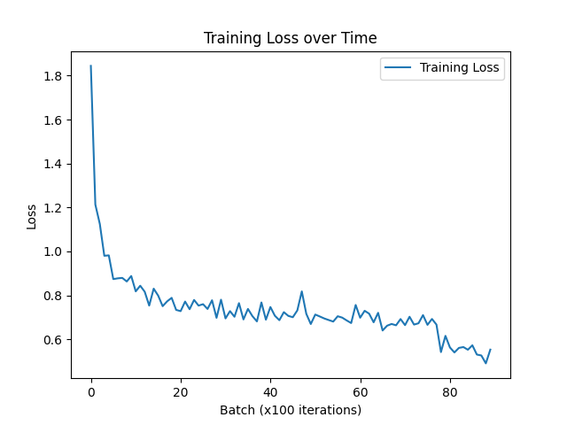
Metric | Value
Test Accuracy | 85.35%

Sparse Model Results

Sparsity Target: 60%

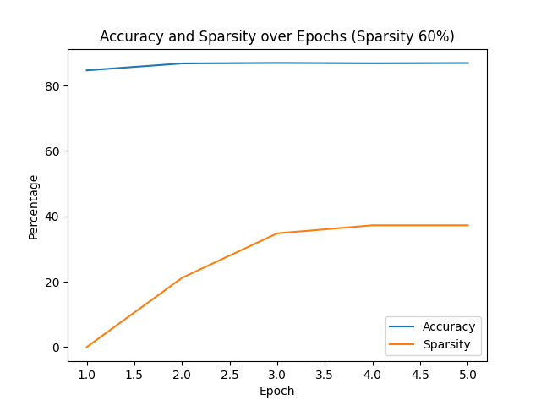 | 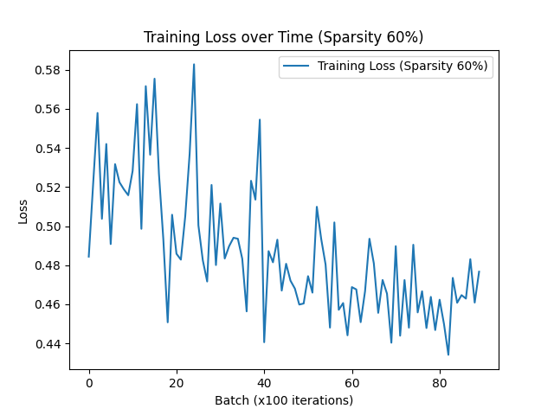

Epoch | Average Sparsity (%) | Accuracy (%) | Accuracy Improvement Compared to Base (%)
1 | 0.00 | 81.90 | -3.45
2 | 21.08 | 82.35 | -3.00
3 | 32.76 | 84.96 | -0.39
4 | 36.41 | 86.53 | +1.18
5 | 36.41 | 84.28 | -1.07

Sparsity Target: 70%

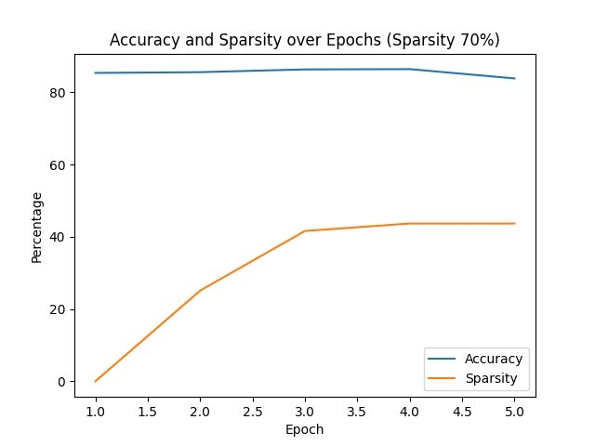 | 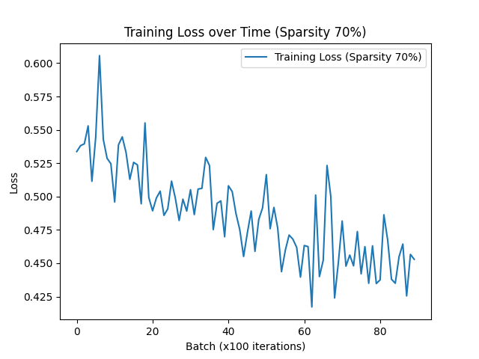

Epoch | Average Sparsity (%) | Accuracy (%) | Accuracy Improvement Compared to Base (%)
1 | 0.00 | 82.25 | -3.10
2 | 24.55 | 86.56 | +1.21
3 | 41.27 | 85.12 | -0.23
4 | 44.99 | 86.53 | +1.18
5 | 44.99 | 83.97 | -1.38

Sparsity Target: 75%

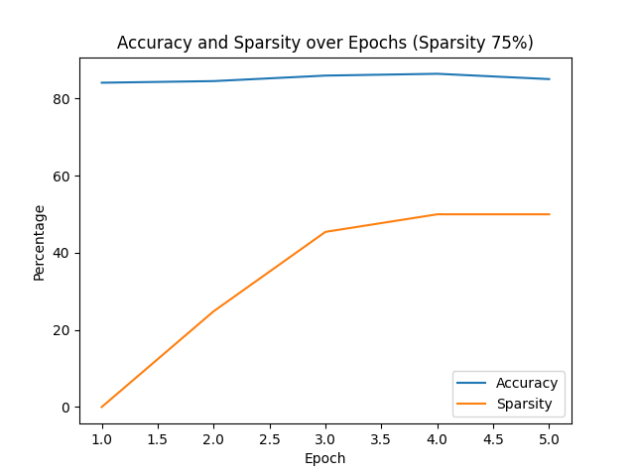 | 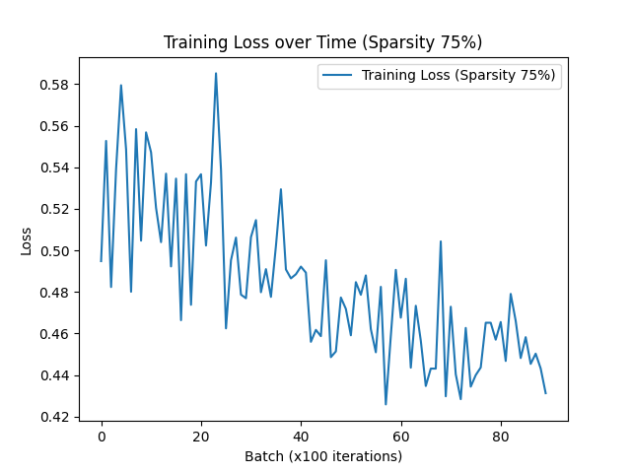

Epoch | Average Sparsity (%) | Accuracy (%) | Accuracy Improvement Compared to Base (%)
1 | 0.00 | 84.04 | -1.31
2 | 26.44 | 83.85 | -1.50
3 | 46.29 | 86.77 | +1.42
4 | 49.97 | 86.56 | +1.21
5 | 49.97 | 86.42 | +1.07

Sparsity Target: 80%
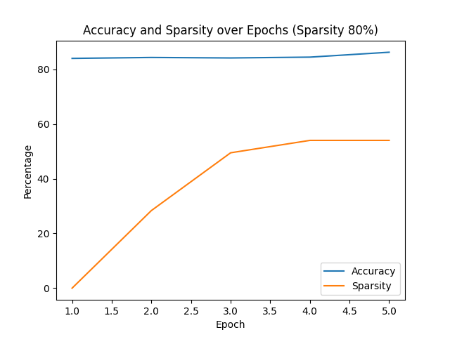 | 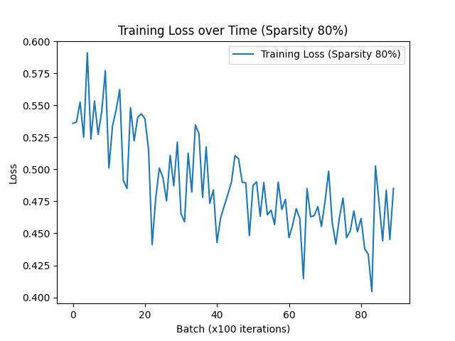

Epoch | Average Sparsity (%) | Accuracy (%) | Accuracy Improvement Compared to Base (%)
1 | 0.00 | 85.82 | +0.47
2 | 29.44 | 85.87 | +0.52
3 | 48.37 | 85.04 | -0.31
4 | 54.42 | 86.23 | +0.88
5 | 54.42 | 86.57 | +1.22

Test the ONNX model after saving
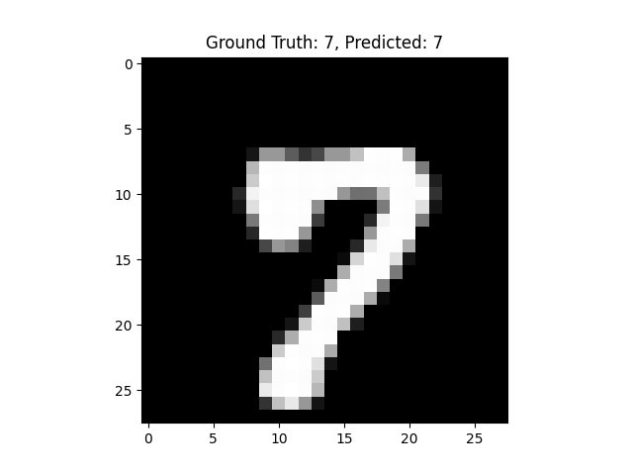
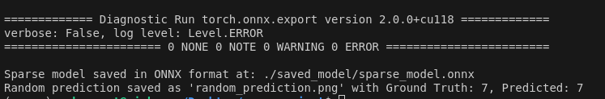

Key Observations
- Base Model Accuracy:
  - The base model achieved 85.35% accuracy on the test data. This serves as a benchmark to evaluate the impact of sparsification on model performance.
- Accuracy Improvement After Sparsification:
  - In most cases, the sparse models improved upon the base model's accuracy. For instance:
    - At 60% sparsity, the peak accuracy was 86.53%, an improvement of +1.18% over the base model.
    - At 70% sparsity, the peak accuracy was also 86.56%, showing a similar improvement of +1.21%.
    - At 75% sparsity, the peak accuracy was 86.77%, marking an improvement of +1.42%.
    - Even at 80% sparsity, the accuracy reached 86.57%, an improvement of +1.22%.
- Performance Under Sparsification:
  - Sparsification effectively reduced model parameters while maintaining or improving accuracy. The model reached its highest accuracy of 86.77% at a 75% sparsity target, demonstrating that the removal of redundant weights can lead to better generalization.
- Initial Drop in Accuracy:
  - Accuracy dropped during the initial epochs due to the model adapting to the pruning process. However, as training progressed, accuracy recovered and often surpassed the base model's performance.

Conclusion
Sparsification not only reduces the number of weights but can also enhance the model's accuracy. The results highlight that with a carefully designed sparsification strategy, models can achieve improved performance and better generalization while being computationally efficient.

